WEBTOOL Wire Rope Cutter 54 mm
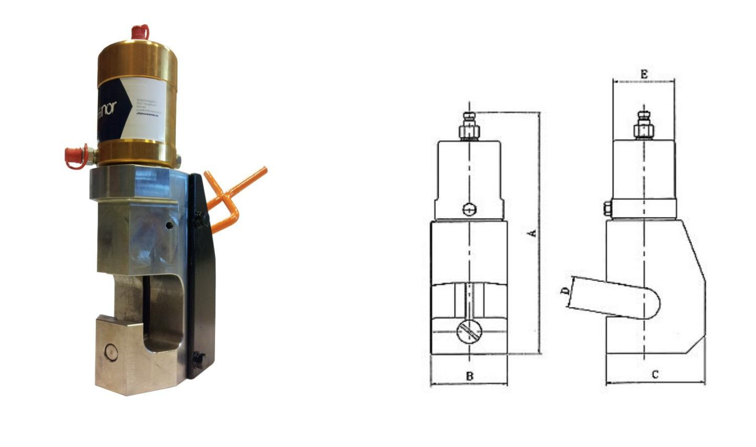

The WEBTOOL wire rope cutter WCOS54(D) is designed for cutting large diameter wire rope up to 54mm diameter in the most hostile environments, under the toughest of conditions. The wire rope cutter has an open sided design to allow easy positioning of the cutter along a rope length, which is particularly useful when cutting in confined spaces. It is supplied with hydraulic return which ensures full retraction of the blade.

Key Features
Proven design
Designed to cut wire rope up to 54 mm diameter
Open sided to allow easy positioning of the cutter along a rope
length particularly useful when cutting in confined spaces.
Hydraulic return

Specifications
Wire Diameter |  | 54 mm
Dimensions (A - B - C - D - E) |  | 710 mm - 125 mm - 165 mm - 55 mm - 107 mm
Weight |  | 30 kg
Operating Pressure |  | 700 bar
Swept Volume |  | 375 cm³

Capabilities
Wire Rope Size |  |  |  | 32 mm | 38mm | 45mm | 51mm
Wire Rope Grade N/mm² |  |  |  | 2160 | 1960 | 1960 | 1770

