PC-1 ROV PUSH CORER
- ROV Sediment Coring Devices
The PC-1 Push core devices are designed to be operated by ROV’s to obtain sediment cores in shallow or deep water applications. The push corers consist of a Perspex tube, one way valve and ROV T-bar handle. Traditionally sediment coring is undertaken remotely from surface vessels, however use of an ROV facilitates the ability to take multiple and high quality cores from highly targeted locations with specific seabed types or habitats, for biological, physical or chemical analysis. The corers comprise two separate parts, the core tube with T bar and the corer housing.
A one way valve at the top of the sample chamber allows water to escape as it is replaced by the sediment core. Upon removal from the sediment, the sample is returned to its housing.. At the base of the housing is a tapered, rubber plug which seals the sample within the assembly. Upon recovery to the surface, the T bar and valve are simply removed and the core with its rubber plug are removed from the housing by a simple twist fitting at the base.

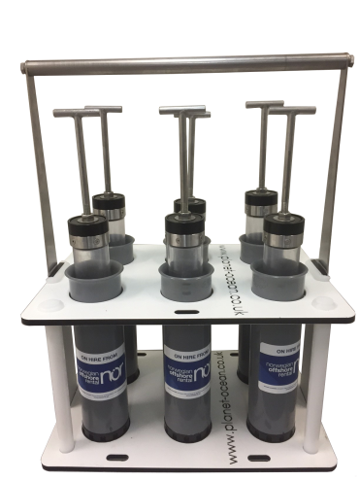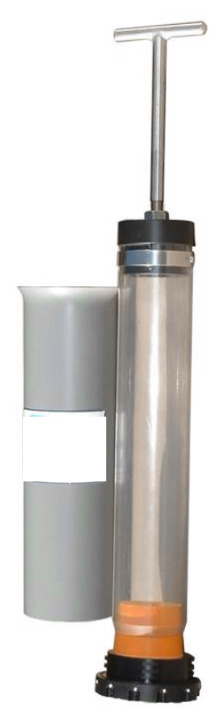

Main features:
- Stainless steel and plastic non corrosive materials
- Pressure balanced for full ocean depth use.
- Rugged – Robust –Reliable
- Simple operation

PC-1 ROV PUSH CORER
Material |  | ABS, PVC glass, Stainess steel, Rubber
Max Operation Depth |  | 6000m
Wight in air (Corer) |  | 0.725Kg
Wight in air (Complete) |  | 1,826Kg
Overall length (includes T bar) |  | 570mm
Core length |  | 280mm
Core diameter |  | 55mm
Core volume |  | 0,665L

